**黑龙江大学**

**实 验 报 告**

|  |  |  |  |  |  |  |
| --- | --- | --- | --- | --- | --- | --- |
| **课程名称** | **计算机操作系统** | | | | | |
| **实验项目名称** | **进程控制** | | | | | |
| **实验时间**  **（日期及节次）** | **2016年09月13日 1-2节** | | | | | |
| **专业** | **计算机** | | **学生所在学院** | | **计算机科学技术学院** | |
| **年级** | **2014级** | | **学号** | | **20123349** | |
| **姓名** | **刘伟** | | **指导教师** | | **朱敬华** | |
| **实验室名称** |  | | | | | |
| **实验成绩** | **预习情况** | **操作技术** | **实验报告** | **附加：综合创新能力** | | **实验**  **综合成绩** |
|  |  |  |  | |  |
| **教师签字** |  | | | | | |

**黑龙江大学教务处**

**实验一 进程控制**

**一．实验名称：**进程控制

**二．实验目的：**利用简单的结构和控制方法模拟进程结构、进程状态和进程控制。

**三．实验内容：**

用PCB表示整个进程实体，利用随机数方法或键盘控制方法模拟进程执行中产生的事件。或者利用鼠标或者键盘中断的基于图形接口方式的进程控制管理。

**四．实验代码**

/**

* 定义一个队列类

* @dataStore 空数组

* @enqueue 入队

* @dequeue 出队

* @front 返回队首元素

* @back 返回队尾元素

* @show 打印队列

* @isEmpty 判断队列是否为空

*/

function Queue()

{

this.dataStore = [];

}

Queue.prototype.enqueue = function(element)

{

this.dataStore.push(element);

}

Queue.prototype.dequeue = function()

{

return this.dataStore.shift();

}

Queue.prototype.front = function()

{

return this.dataStore[0];

}

Queue.prototype.back = function()

{

return this.dataStore[this.dataStore.length-1];

}

Queue.prototype.show = function()

{

var retStr = "";

for(var i = 0; i < this.dataStore.length; i++)

{

retStr += this.dataStore[i] + "\n";

}

return retStr;

}

Queue.prototype.isEmpty = function()

{

if(this.dataStore.length == 0)

{

return true;

}

else

{

return false;

}

}

/**

* 定义一个 PCB 类

* @pid 进程pid

* @title 进程title

* @get_pid 返回pid

* @get_title 返回title

*/

function PCB(pid,title)

{

this.pid = pid;

this.title = title;

}

PCB.prototype.get_pid = function()

{

return this.pid;

};

PCB.prototype.get_title = function()

{

return this.title;

};

/**

* 生成一个随机pid

*/

var create_pid = function()

{

var myDate = new Date();

var myYear = myDate.getYear();

var myMonth = myDate.getMonth();

var myHour= myDate.getHours();

var myMinute = myDate.getMinutes();

var mySecond = myDate.getSeconds();

var myRandom = ~~(Math.random()*1000);

var pid = myYear+myMonth+myHour+myMinute+mySecond+myRandom;

return pid;

}

/**

* 创建进程 create_process

*/

var create_process = function(title)

{

var pid = create_pid();

var title = title;

var pcb = new PCB(pid,title);

readyQue.enqueue(pcb);

}

/**

* 阻塞进程 block_process

*/

var block_process = function()

{

if(readyQue.isEmpty())

{

console.log("No ready process running");

}

else

{

blockQue.enqueue(readyQue.front());

readyQue.dequeue();

}

}

/**

* 唤醒进程 wake_process

*/

var wake_process = function()

{

if(blockQue.isEmpty())

{

console.log("No blocked process running");

}

else

{

readyQue.enqueue(blockQue.front());

blockQue.dequeue();

}

}

/**

* 时间片到 time_end

*/

var time_end = function()

{

if(readyQue.isEmpty())

{

console.log("No ready process running");

}

else

{

running = readyQue.front();

readyQue.dequeue();

readyQue.enqueue(running);

}

}

/**

* 结束进程 kill_process

*/

var kill_process = function()

{

if(readyQue.isEmpty())

{

console.log("No ready process running");

}

else

{

readyQue.dequeue();

running = readyQue.front();

}

}

/**

* 显示进程信息 show_process

*/

var show_process = function()

{

var readyStr = "";

var blockStr = "";

if(readyQue.front())

{

console.log("running: " + readyQue.front().title);

}

for(var j=1; j<readyQue.dataStore.length; j++)

{

readyStr += readyQue.dataStore[j].title+" ";

}

console.log("ready: " + readyStr);

for(var k=0; k<blockQue.dataStore.length; k++)

{

blockStr += blockQue.dataStore[k].title+" ";

}

console.log("blocked: " + blockStr);

}

var running = "";

var readyQue = new Queue();

var blockQue = new Queue();

var readline = require("readline");

var rl = readline.createInterface({

input: process.stdin,

output: process.stdout

});

rl.setPrompt("OS Demo > ");

rl.prompt();

rl.on('line',function(input){

var shell = input.trim();

switch(shell){

case '-h':

console.log("\n****************************************\n"+"\n-h ---- helpInfo\n-a ---- authorInfo\n-i ---- demoInfo\n-c ---- create a process\n-b ---- blocked a process\n-w ---- wake a process\n-t ---- time end\n-k ---- kill currenty process\n exit ---- exit\n"+"\n****************************************\n");

break;

case '-i':

console.log("\n This is a OS Process Management Demo! \n");

break;

case '-a':

console.log("\n liuwei NO.20123349 \n");

break;

case '-c':

rl.question('please enter process title:',function(answer){

var title = answer;

create_process(title);

show_process();

});

break;

case '-b':

block_process();

show_process();

break;

case '-w':

wake_process();

show_process();

break;

case '-t':

time_end();

show_process();

break;

case '-k':

kill_process();

show_process();

break;

case 'exit':

console.log("\n You had closed OS Process Management Demo! \n");

rl.close();

process.exit(0);

break;

default:

console.log("\n*******************************************************************************\n"+

"*This is a OS Process Management Demo,you can input '-h' see more information!*"+

"\n*******************************************************************************\n"

); }

rl.prompt();

});

**五．实验截图：**

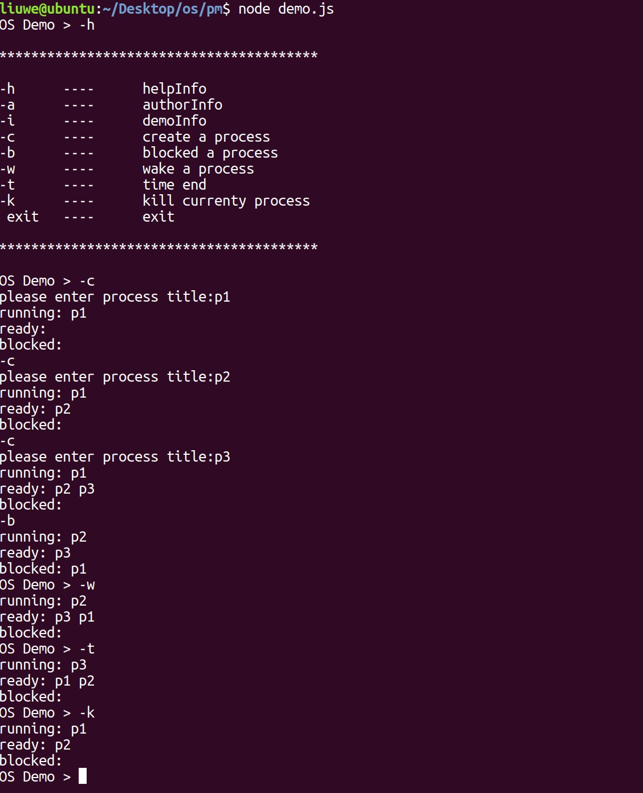

**六．实验心得：**

通过此次试验了解了进程控制块PCB的定义与创建方式，了解了进程控制的基本概念，了解了进程各种状态之间的转换以及转换发生的基本条件。